Introduction
Chapter
1
Like a good bridge, good software must be built upon a solid foundation.
the Washington Bridge Foundation Libraries (WBFL) provide a solid foundation for the development of bridge engineering software. The WBFL consists of the Application Services Layer (ASL), the Bridge Engineering Tool Kit (BETK), and the Bridge Application Library (BAL). Each of these subsystems provide various programming services to software developers in the form of C++ class libraries, utility classes and frameworks. The relationship between the WBFL subsystems, the operating system, and bridge applications is shown in Figure 1.

Documentation Set
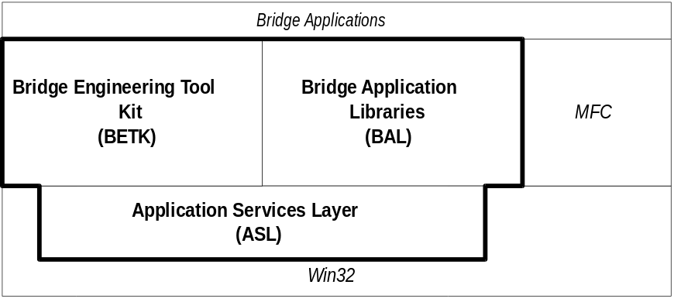
Figure 1
The WBFL itself is not an application framework, rather it is designed to be used with application frameworks such as Microsoft Foundation Classes, Borland’s Object Windows Library, and IBM’s Open Class.
This documentation set consists of seven manuals. The first manual is this Overview document which provides an introduction and high level view of the Washington Bridge Foundation Libraries. The next three manuals provided detailed specification for the WBFL subsystems. The final three manuals are user guides for the WBFL subsystems. This documentation is designed to serve two audiences, the implementation/maintenance programmer and the bridge application developer. The specification manuals document the analysis, design, and construction specifications of the various software components for the implementation/maintenance programmer. The user guides provide detailed instructional information bridge application developer. The documentation is as follows:
- Volume 1 - WBFL Overview
- Volume 2 - ASL Specifications
- Volume 3 - BETK Specifications
- Volume 4 - BAL Specifications
- Volume 5 - ASL User Guide
- Volume 6 - BETK User Guide
- Volume 7 - BAL User Guide

Application Services Layer
The Application Services Layer is the lowest level of the WBFL. It consists of packages that provide system services, unit services, generic containers, object persistence, and diagnostics and debugging.

System Services
System services package provides low level programming services. The date and time service classes are used for accessing and manipulating dates and times. The 2D and 3D geometric primitive classes represent primitive geometrical constructs.

Unit Services
The Unit Services package provides unit conversion and System Units (internal base unit) management services. The unit conversion services provide an extensible, general purpose unit conversion mechanism. The System Units management service provides a convenient method for managing the internal base units of your system.

Math Services
The Math Services Package provides linear algebra and numerical analysis tools. The linear algebra library provides matrix and vector manipulation and arithmetic services. The numerical analysis library provides services such as curve fitting, root finding, and equation solvers.

Graphics Tools
The graphics tools package provides low level computer graphic tools. The point mapping class can be used to map a world coordinate space into a device coordinate space.

Generic Containers
The generic containers package provides structured data storage services. This package includes container classes for vectors, sets, bags, queues, maps, and lists. Services are also provide to iterate and manipulate containers.

Object Persistence
The object persistence package provides persistent stream classes for creating streamable objects. (Probably won’t be implemented anytime soon, but this is where it will go)

Diagnostic and Debugging Services
The diagnostic and debugging services package provide tools for debugging applications. The services include compile-time and run-time messaging as well as run-time assertions and exceptions.

Bridge Engineering Tool Kit
The Bridge Engineering Tool Kit provides a variety of packages for solving engineering problems. The BETK contains services for 2D geometric modeling, 3D geometric modeling, Coordinate Geometry (COGO) for highway structures, linear algebra, numerical analysis, finite element analysis, material modeling, structural analysis of bridges, bridge product modeling, and solutions to engineering problems such as bi-axial analysis of structural members.

Engineering Tools
The engineering tools package provides low level classes that encapsulate simple engineering calculations. This package contains classes for 2D and 3D Mohr’s circle calculations and several common LRFD code equations.

2D Geometric Modeling
The 2D Geometric Modeling Package provides modeling services for two dimensional shapes and sections for structural members.

3D Geometric Modeling
The 3D Geometric Modeling Package provides solid modeling services for three dimension objects.

COGO
The COGO Package provides services for coordinate geometry calculations of highway structures.

Finite Element Analysis
The Finite Element Analysis Package provides general purpose structural analysis services. This package can be used for static and dynamic analysis of two and three dimensional truss, frame, plate and solid models. (A lofty goal, but it will have to be reached someday. For now, static analysis of 2D plane frame structures will suffice).

Bridge Analysis
The Bridge Analysis Package is a special purpose structural analysis tool. This tools allows structural analysis to be performed for a bridge structure, in terns of the bridge and its components. It also encapsulates bridge specific structural analysis ideas, such as live load models.

Bridge Modeling
The Bridge Modeling Package provides product modeling services for bridge structures. This package is used to capture a real bridge structure in the computer for evaluation. This package encapsulates bridge domain information such as girders, slabs, columns, footings, and reinforcing bars.

Engineering Mechanics
The Engineering Mechanics Package provides services for solving generalized engineering problems. The two most prominent services in the package are a moment-curvature analytical model and a biaxial analysis model.

Engineering Services
The Engineering Services Package provides services for solving specific engineering problems. The objects in this package consist of a variety of builders and engineers.

Bridge Application Library
The Bridge Application Library provides libraries and frameworks needed to create robust engineering applications. Services include file parsers, transaction management tools, graphing tools, GUI interaction tools, and reporting tools. While the BETK provides services for solving engineering problems, the Bridge Application Library provides the packages necessary to create robust engineering applications.

File Parsing Services
It is frequently necessary to provide backwards compatibility with older engineering programs. These programs have a variety of file formats which need to be read or written. The file parsing services provide classes to assist with this task.

Transaction Management Services
In the interactive software we have become accustomed to, we have come to expect Undo capabilities. The transaction management services package provides a framework for processing transactions, repeating transactions, undoing transactions, and redoing transactions.

Graphing Services
The Graphing Services Package provide a general purpose X-Y graphing tool that is useful for visualizing analysis results.

GUI Interaction Services
This package will provide a HotDraw or jKit/GO like services.

Unit Management
The unit management package provides a library based management approach to indirect units of measure.

Reporting Services
The reporting services packages provides software developers with a full featured, flexible, and extensible system for creating reports.

Event Dispatching Services
Provides a mechanism to dispatch events.

Agent/Broker Framework
Provides a framework that user the agent/broker architecture.

